# CS 255 DriverPass System Design Document

Emily Domoracki | October 2022 | Professor Kim-Marie Foss

## UML Diagrams

### UML Use Case Diagram

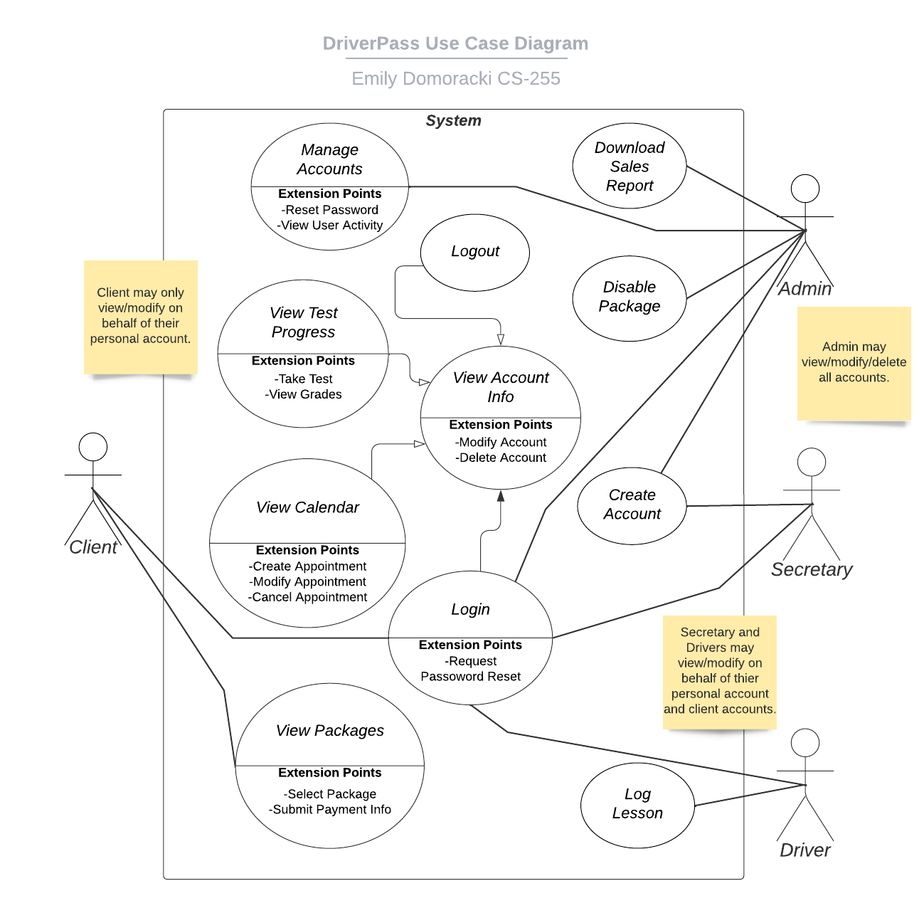

### UML Activity Diagrams

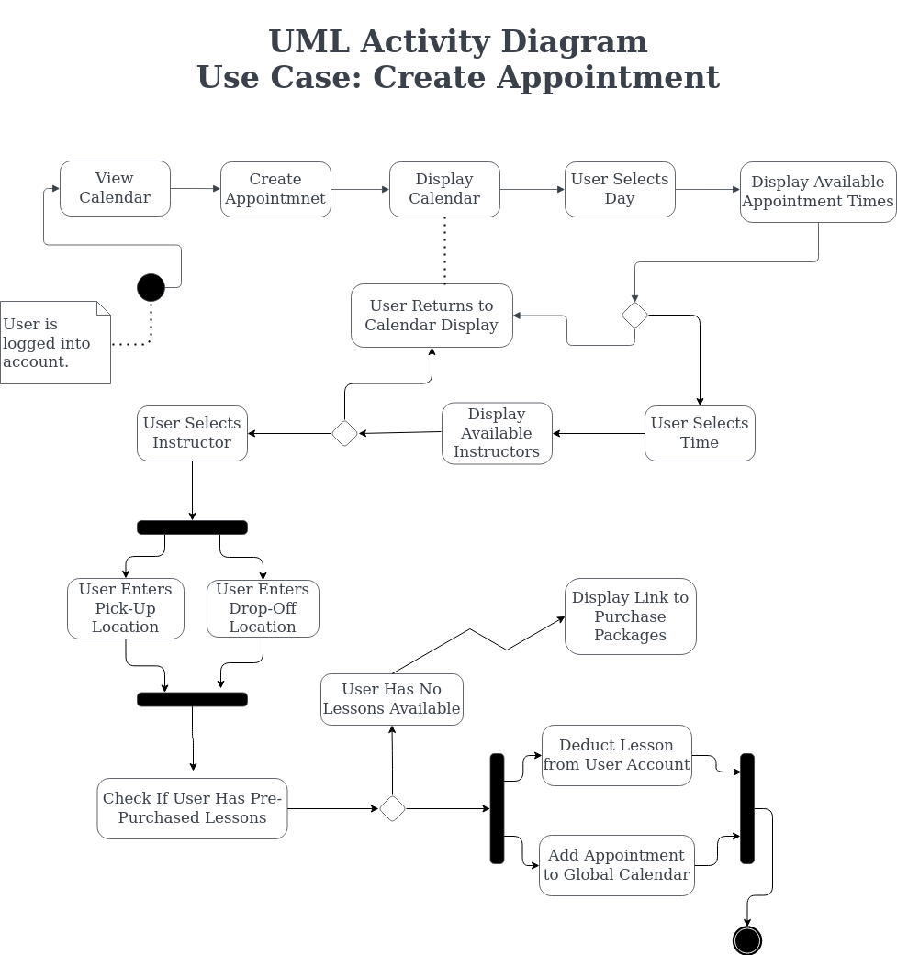

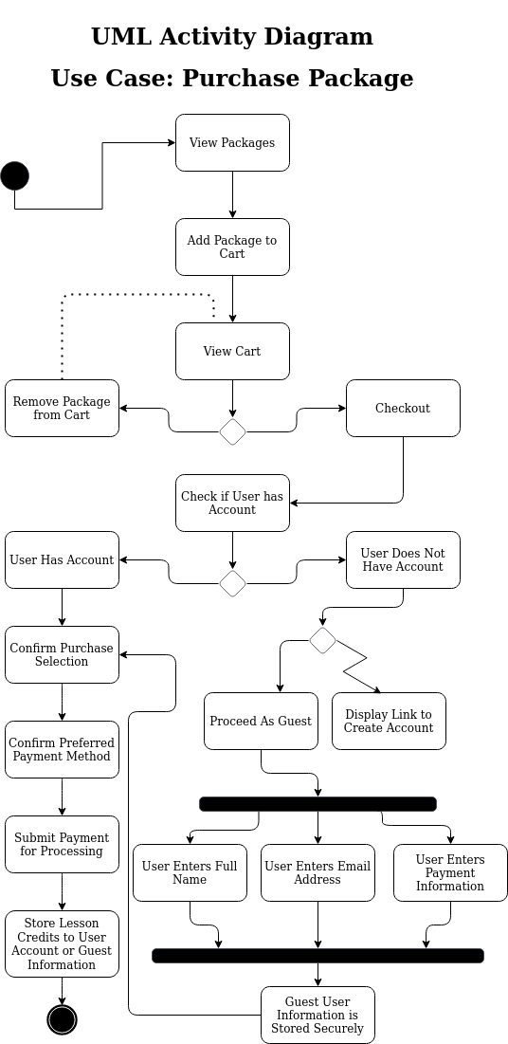

### UML Sequence Diagram

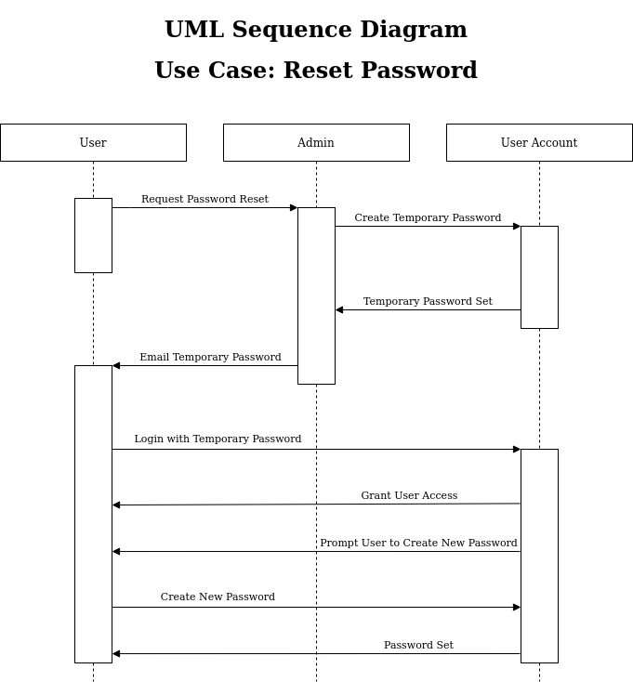

### UML Class Diagram

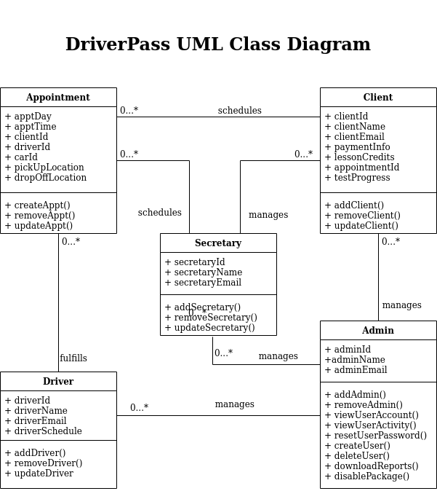

## Technical Requirements

*[Based on the diagrams you have created, describe the technical requirements of your system. These requirements should address the required hardware, software, tools, and infrastructure necessary for your system design.]*

* System software is web hosted
* System requires cloud database
* Methods for communications between users outside of system necessary
* System use and management requires internet access
* Password security for user accounts
* Encryption of personal information and payment details
* Addition of new packages will require professional programming